SIMATS ENGINEERING ASSESSMENT TOOL 1

COURSE NAME: Database Management Systems COURSE CODE: CSA05

COURSE OUTCOME COVERED

CO3: Analyze relational databases using functional dependencies, normalization (1NF to 5NF), and key constraints to identify redundancy and ensure data integrity. (BL2, BL3)

Activity Tool : Experiments (High) Assessment Tool Weightage: 40%

QUESTIONS Total Marks: 50
Q.N  o | Question | Bloom's Level | Marks
1 | For the relation STUDENT_COURSE(SID, SName, CID, CName, Instructor, Grade), identify all functional dependencies and determine the candidate keys. | BL2 – Understand | 5
2 | Demonstrate the process of converting an unnormalized relation into 1NF with step-by-step justification and example. | BL3 – Apply | 5
3 | Given relation R(A,B,C,D,E) with FDs: A→BC, BC→D, D→E. Analyze and decompose it to 2NF eliminating partial dependencies. | BL3 – Apply | 5
4 | Apply 3NF decomposition on the relation EMPLOYEE(EmpID, EmpName, DeptID, DeptName, ManagerID) with transitive dependencies. | BL3 – Apply | 5
5 | Verify whether R(A,B,C,D) with FDs: AB→C, C→D, D→A is in BCNF. If not, decompose it into BCNF. | BL3 – Apply | 5
6 | Experimentally verify lossless-join decomposition for a given relation using the tabular (Chase) algorithm. | BL3 – Apply | 5

7 | Identify the multi-valued dependencies in TEACHER(TID, Subject, Hobby) and decompose it into 4NF. | BL3 – Apply | 5
8 | Demonstrate how join dependencies lead to redundancy. Decompose a given relation to 5NF (Project-Join Normal Form). | BL3 – Apply | 5
9 | Given a poorly designed database schema for a college, identify all anomalies (insertion, deletion, update) and normalize it to 3NF. | BL2 – Understand | 5
10 | Compute the closure of attribute sets for the given FDs and determine all candidate keys for the relation. | BL3 – Apply | 5

Code of Conduct:

I JEROLD SAMUEL J (192571052) (Name / Reg No) certify that this submission is my original work and that I have adhered to the guidelines specified for this assessment. I understand that any violation of academic integrity rules will result in disciplinary action.
Signature of the student:
JEROLD SAMUEL J (192571052)

ANSWERS:

1.For the relation STUDENT_COURSE(SID, SName, CID, CName, Instructor, Grade), identify all functional dependencies and determine the candidate keys.

CODE:

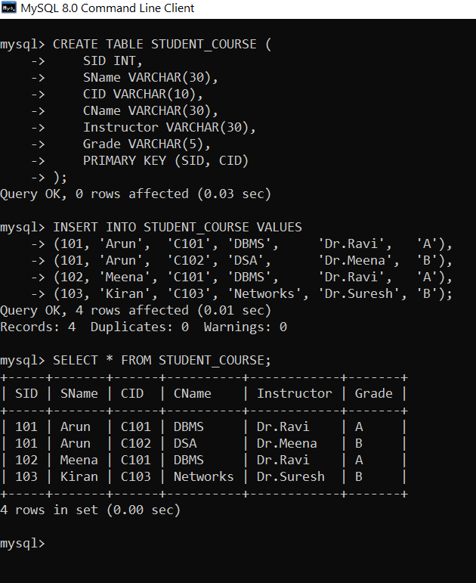

QUERY 1 – Verify SID → SName

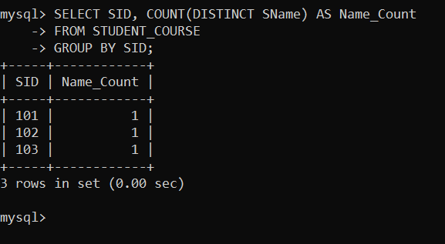

Therefore:

  - SID → SName

QUERY 2 – Verify CID → CName, Instructor
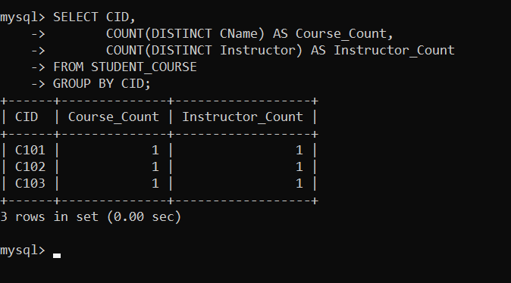

Therefore:

  - CID → CName
  - CID → Instructor

QUERY 3 – Verify Candidate Key (SID, CID)

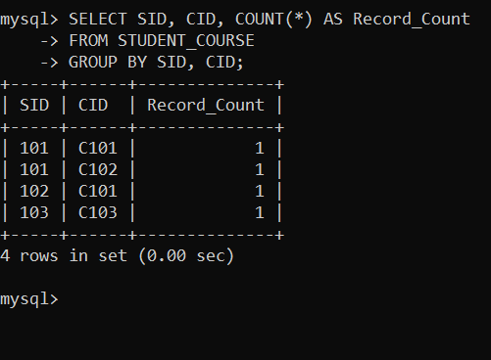

Every (SID, CID) combination uniquely identifies one record. Therefore:
  - (SID, CID) → Grade

  - Candidate Key = (SID, CID)

FUNCTIONAL DEPENDENCIES:

  - SID → SName
  - CID → CName
  - CID → Instructor
  - (SID, CID) → Grade

CANDIDATE KEY:

  - (SID, CID)

Demonstrate the process of converting an unnormalized relation into 1NF with step-by-step justification and example.
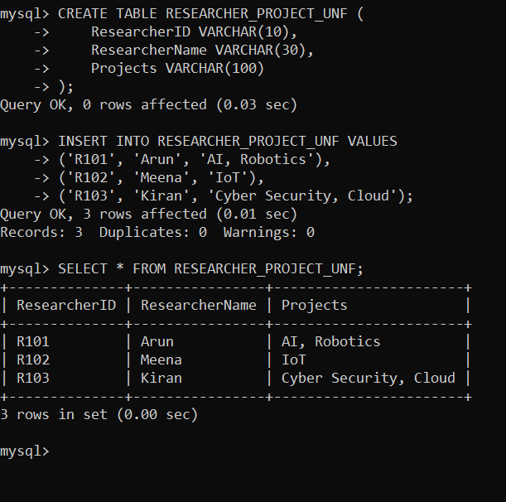

CONVERT TO 1NF:

Each project is placed in a separate row.

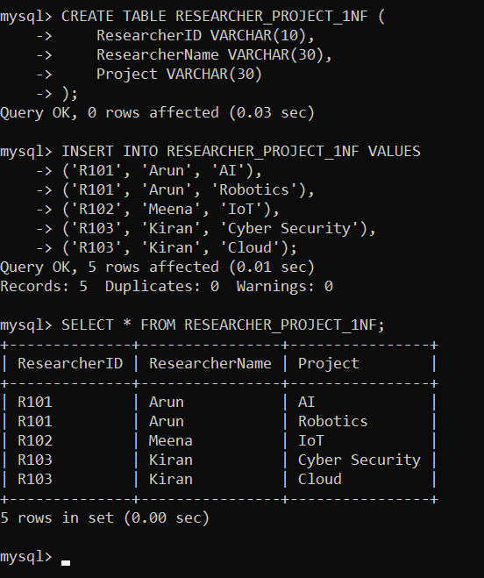

- Given relation R(A,B,C,D,E) with FDs: A→BC, BC→D, D→E. Analyze and decompose it to 2NF eliminating partial dependencies.

CODE:

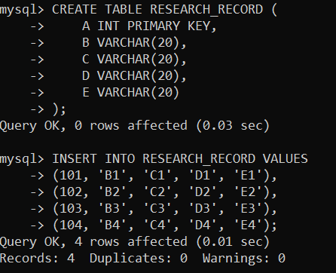
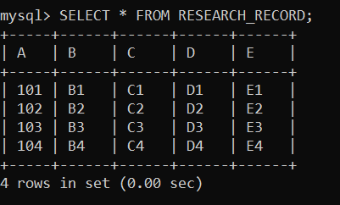

QUERY – Verify Candidate Key A

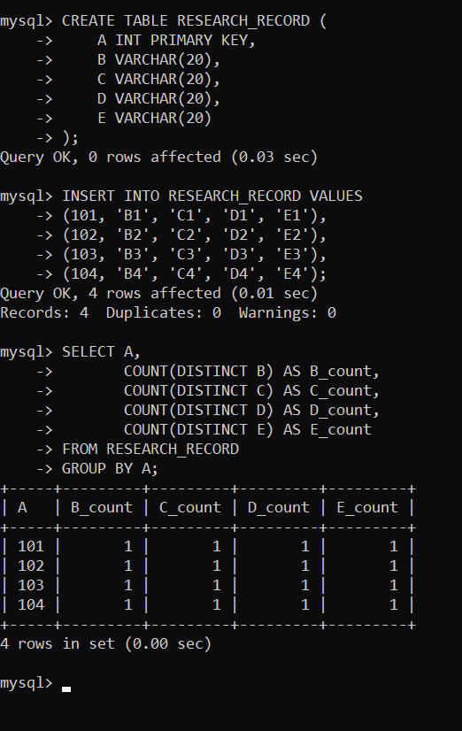

A+ = {A,B,C,D,E}

Therefore, Candidate Key = A.

Apply 3NF decomposition on the relation EMPLOYEE(EmpID, EmpName, DeptID, DeptName, ManagerID) with transitive dependencies.
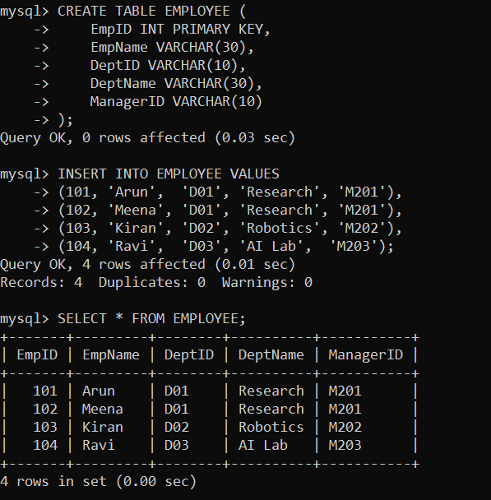

FUNCTIONAL DEPENDENCIES
  - EmpID → EmpName, DeptID
  - DeptID → DeptName, ManagerID

Here, the transitive dependency is:

  - EmpID → DeptID → DeptName, ManagerID

DeptName and ManagerID depend on EmpID through DeptID, creating a transitive dependency.
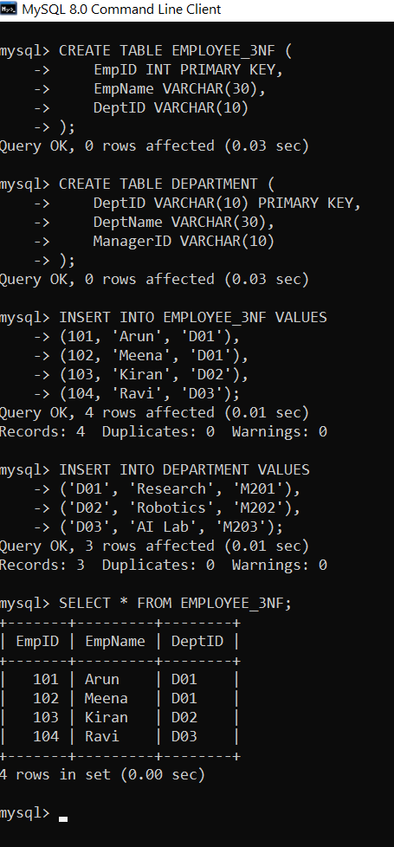

DECOMPOSE INTO 3NF

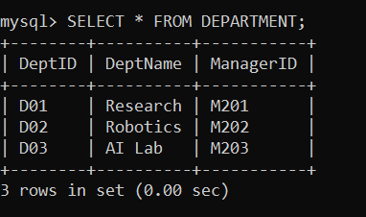

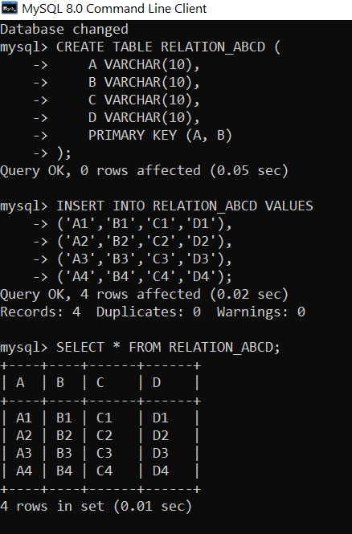
- Verify whether R(A,B,C,D) with FDs: AB→C, C→D, D→A is in BCNF. If not, decompose it into BCNF.

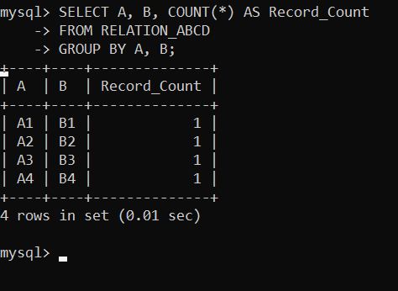

Therefore, AB is a candidate key.

CREATE FIRST BCNF DECOMPOSITION:

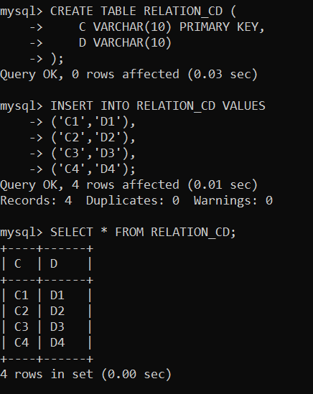

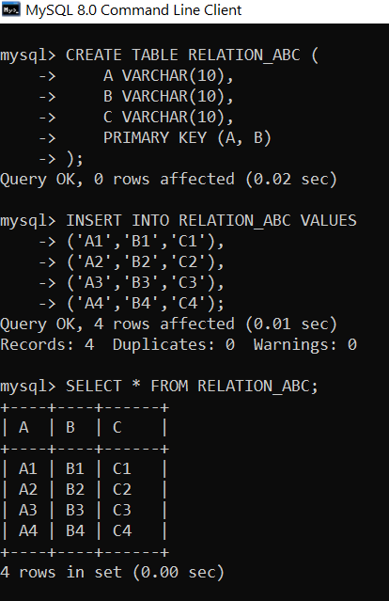

From:

  - C → D Decompose into:
  - R1(C,D)
  - R2(A,B,C)

SECOND BCNF DECOMPOSITION:

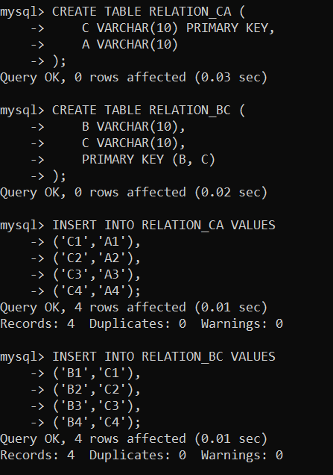

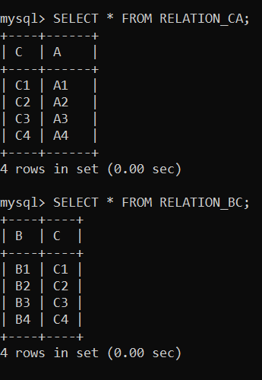

Final Decomposition:

  - R1(C,D)
  - R2(C,A)
  - R3(B,C)

Experimentally verify lossless-join decomposition for a given relation using the tabular (Chase) algorithm.

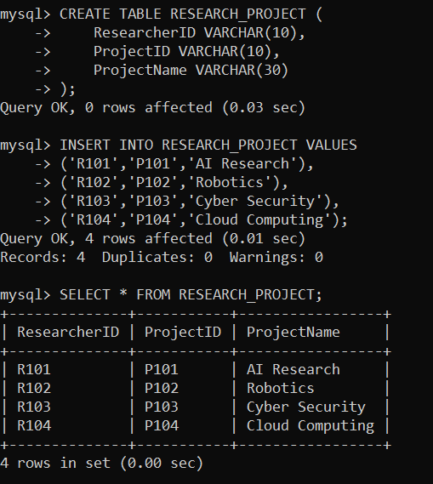

CREATE DECOMPOSED RELATIONS
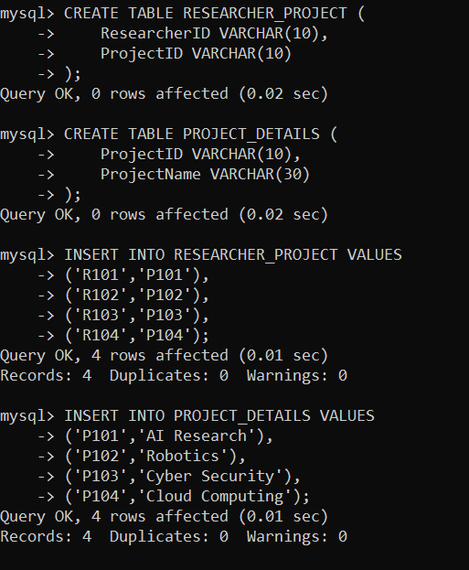

CHASE TABLE:

Initial Chase Table:

Row | ResearcherID | ProjectID | ProjectName
R1 | a1 | a2 | b3
R2 | b1 | a2 | a3

FD: ProjectID → ProjectName

Since both rows have the same ProjectID (a2), ProjectName takes the common distinguished value (a3).

Row | ResearcherID | ProjectID | ProjectName
R1 | a1 | a2 | a3
R2 | b1 | a2 | a3

A row contains all distinguished symbols. Therefore, the decomposition is LOSSLESS.

VERIFY USING SQL JOIN:

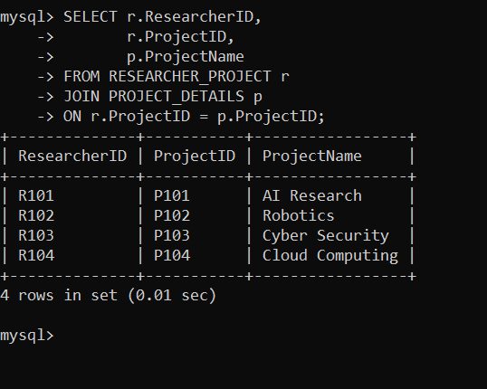

Identify the multi-valued dependencies in TEACHER(TID, Subject, Hobby) and decompose it into 4NF.

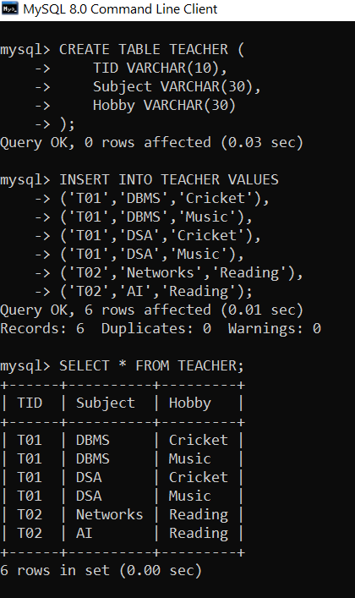

MULTI-VALUED DEPENDENCIES

  - TID →→ Subject
  - TID →→ Hobby

DECOMPOSE INTO 4NF:

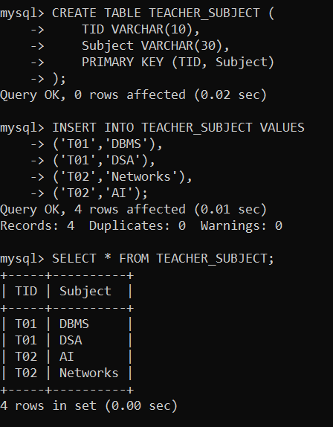

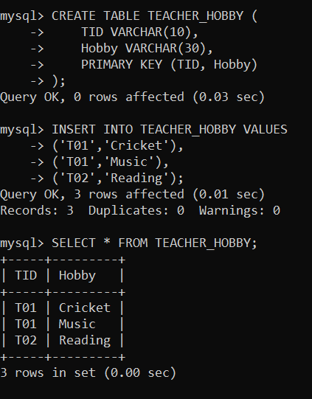

  - TID →→ Subject
  - TID →→ Hobby

Therefore, the original relation contains independent multi-valued dependencies. Decomposition:
  - TEACHER_SUBJECT(TID, Subject)
  - TEACHER_HOBBY(TID, Hobby)

- Demonstrate how join dependencies lead to redundancy.Decompose a given relation to 5NF (Project-Join Normal Form).

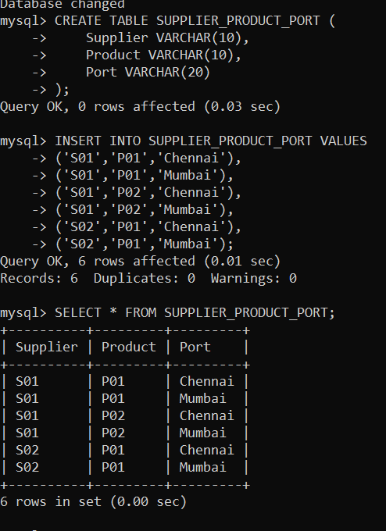

DECOMPOSITION INTO 5NF

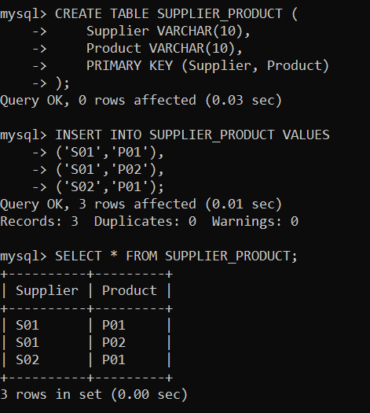

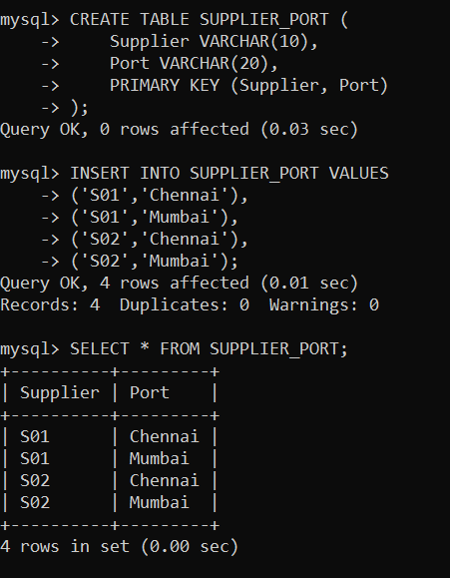

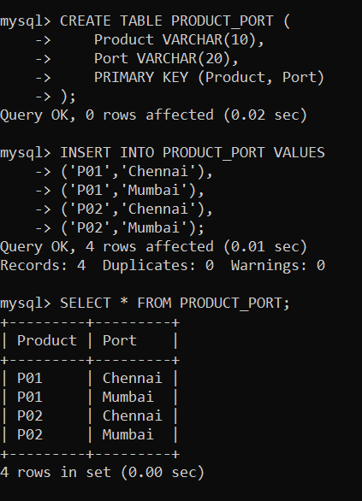

Original Relation:

  - SUPPLIER_PRODUCT_PORT(Supplier, Product, Port) Decomposition:
  - SUPPLIER_PRODUCT(Supplier, Product)
  - SUPPLIER_PORT(Supplier, Port)
  - PRODUCT_PORT(Product, Port)

The three relations remove the redundancy caused by the independent associations and represent the join dependency separately.

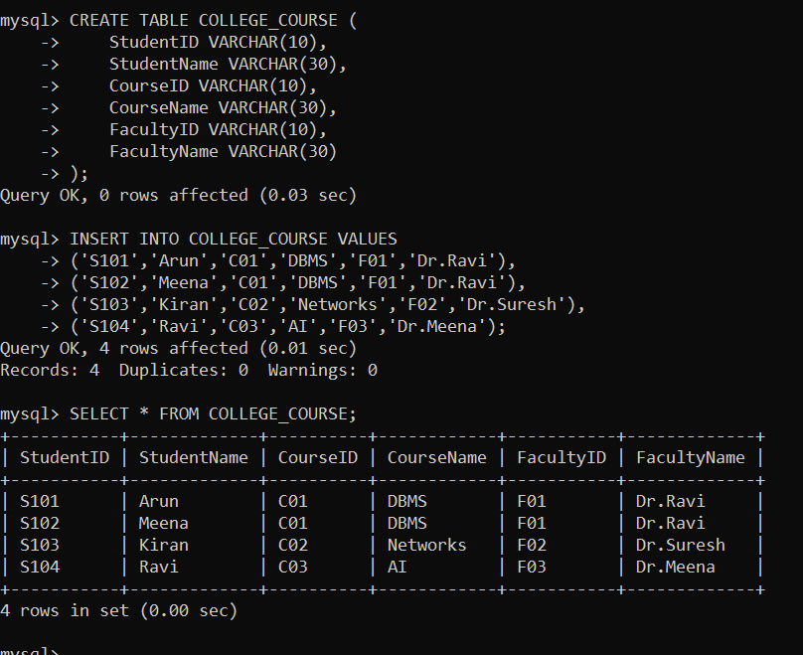
Given a poorly designed database schema for a college, identify all anomalies (insertion, deletion, update) and normalize it to 3NF.

Functional Dependencies

  - StudentID → StudentName
  - CourseID → CourseName, FacultyID
  - FacultyID → FacultyName Therefore, there is a transitive dependency: CourseID → FacultyID → FacultyName be lost.

DECOMPOSE INTO 3NF:
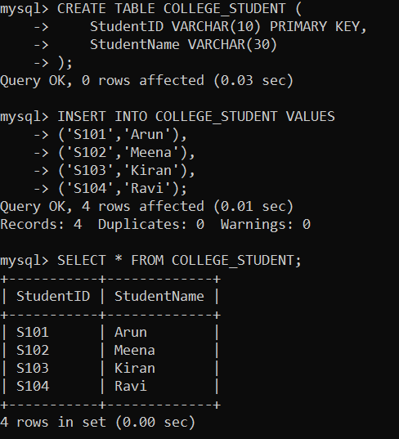

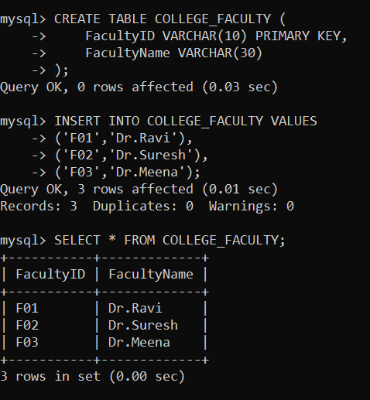

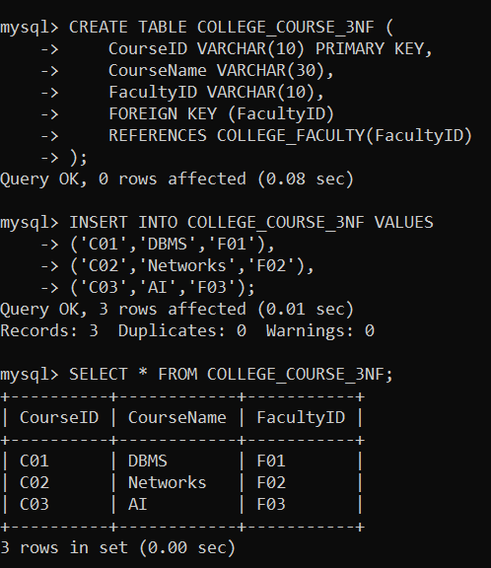

Original:

COLLEGE_COURSE

  - (StudentID, StudentName, CourseID, CourseName, FacultyID, FacultyName) 3NF Decomposition:
  - COLLEGE_STUDENT(StudentID, StudentName)
  - COLLEGE_COURSE_3NF(CourseID, CourseName, FacultyID)
  - COLLEGE_FACULTY(FacultyID, FacultyName)

- Compute the closure of attribute sets for the given FDs and determine all candidate keys for the relation.
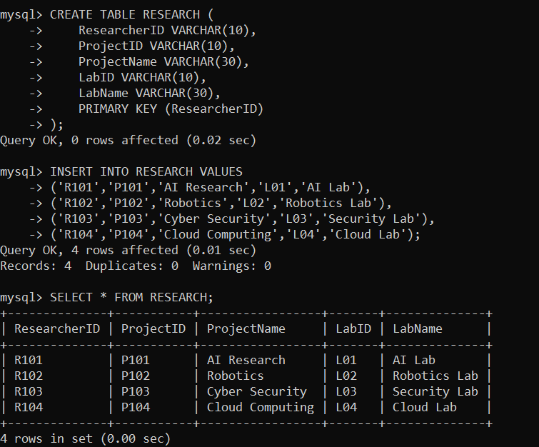

FUNCTIONAL DEPENDENCIES

  - ResearcherID → ProjectID
  - ProjectID → ProjectName, LabID
  - LabID → LabName

  - Candidate Key = ResearcherID

SQL VERIFICATION
